Problem-14
Problem Definition: Develop an admin dashboard that displays user statistics, student count, event count and latest registrations. Restrict access to admin users only and show dynamic menu options based on role.
Code:
admin_dashboard14.php:
1. Role-Based Access Control

require_once "auth10.php";

if (!isset($_SESSION["role"]) || $_SESSION["role"] !== "admin") {
http_response_code(403);
exit("Access denied. Admin privileges are required.");
}

2. Dashboard Statistics

$userCount = $conn->query(
"SELECT COUNT(*) AS total FROM users"
)->fetch_assoc()["total"];

$studentCount = $conn->query(
"SELECT COUNT(*) AS total FROM students"
)->fetch_assoc()["total"];

$eventCount = $conn->query(
"SELECT COUNT(*) AS total FROM events12"
)->fetch_assoc()["total"];

3. Latest Registrations
$latestUsers = $conn->query(
"SELECT user_id, name, email, role, created_at
FROM users
ORDER BY created_at DESC
LIMIT 5"
);

4. Audit Log Insertion

$stmt = $conn->prepare(
"INSERT INTO audit_logs14 (user_id, action, details)
VALUES (?, ?, ?)"
);

$userId = (int)$_SESSION["user_id"];
$action = "Dashboard Access";
$details = "Administrator opened the dashboard.";

$stmt->bind_param("iss", $userId, $action, $details);
$stmt->execute();
$stmt->close();

role_menu14.php:
$role = $_SESSION["role"] ?? "";
?>

<nav>
<a href="dashboard10.php">Dashboard</a>

<?php if ($role === "admin"): ?>
<a href="admin_dashboard14.php">Admin Dashboard</a>
<a href="students11.php">Student Management</a>
<a href="event_management12.php">Event Management</a>
<a href="audit_log14.php">Audit Log</a>
<?php else: ?>
<a href="dashboard10.php">My Dashboard</a>
<?php endif; ?>

<a href="logout10.php">Logout</a>
</nav>

audit_log14.php:
$result = $conn->query(
"SELECT audit_logs14.log_id,
audit_logs14.user_id,
users.name,
audit_logs14.action,
audit_logs14.details,
audit_logs14.created_at
FROM audit_logs14
LEFT JOIN users
ON audit_logs14.user_id = users.user_id
ORDER BY audit_logs14.created_at DESC
LIMIT 100"
);

Database Table: audit_logs14:
CREATE TABLE audit_logs14 (
log_id INT AUTO_INCREMENT PRIMARY KEY,
user_id INT DEFAULT NULL,
action VARCHAR(100) NOT NULL,
details TEXT,
created_at TIMESTAMP DEFAULT CURRENT_TIMESTAMP
);

Output:
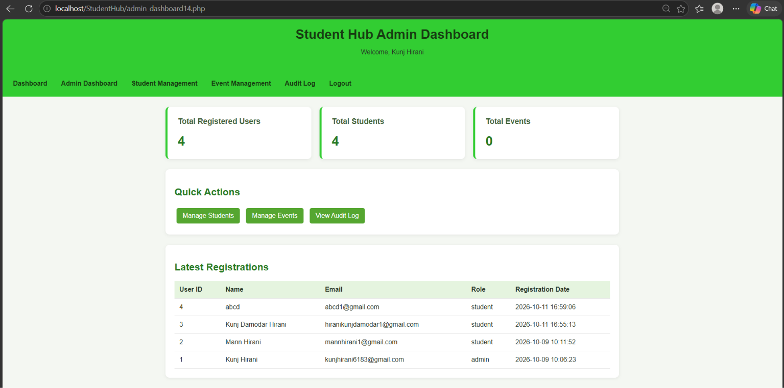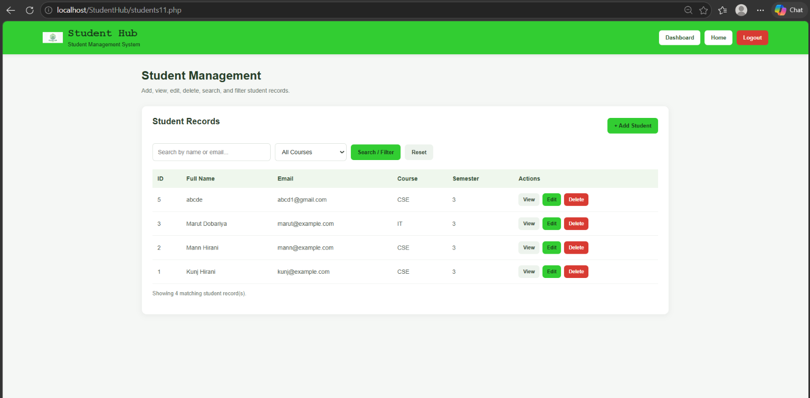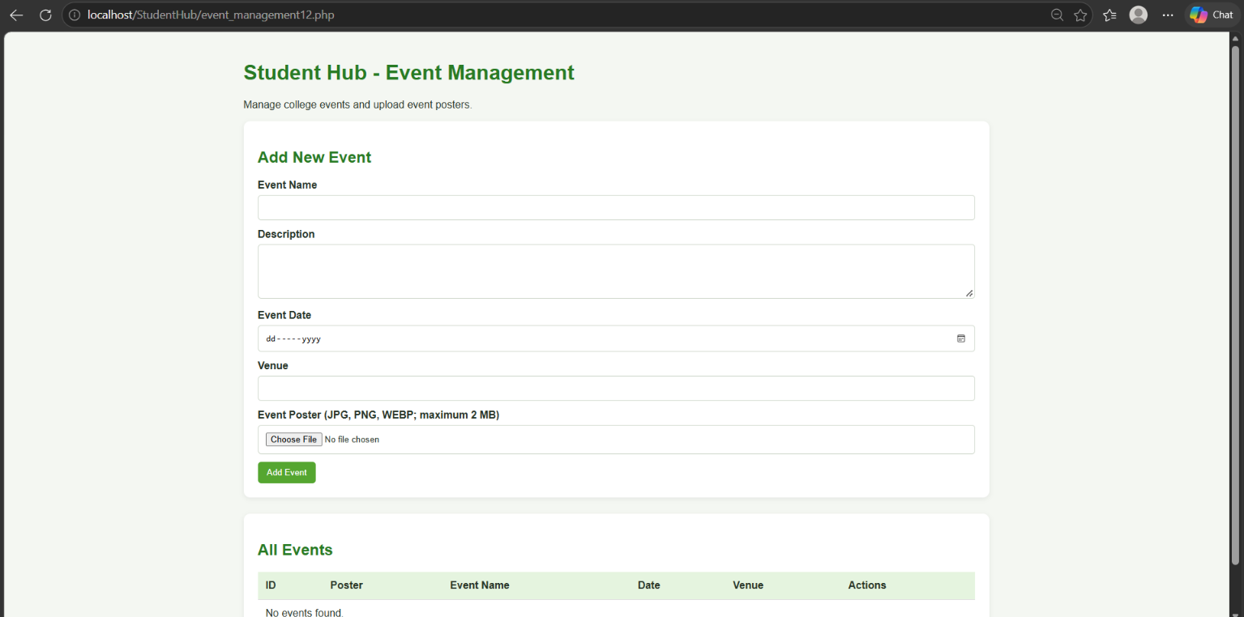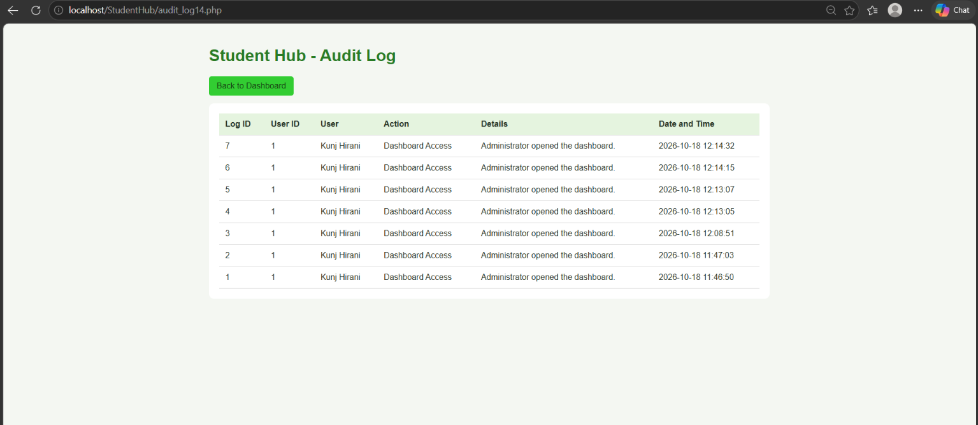
Github link:
https://github.com/kahanipatel156-dev/WDF-Batch-B/upload/main/Practical%2014

